EE 97 Fall 2016

Thurs. 1330

Lab #4 Function Generator and Oscilloscope

Sidarth Shahri

Partner: Christian Lopez

Station 5, 10

Submitted 6 October 2016

Lab #4 Function Generator and Oscilloscope

**Experiment 1**

A function generator is used to produce a waveform of different varieties (sine, square, triangle, ramp, and noise.) In this experiment, the HP 33120A was used to generate various functions. This function generator was plugged directly into an oscilloscope’s channel.

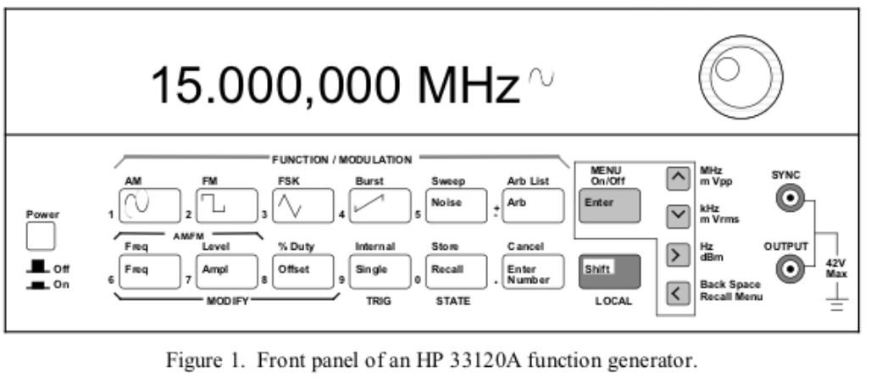

An oscilloscope can display the voltage v. time of an input on a two-dimensional graph. An oscilloscope has various knobs for adjusting the graph to be readable and visible within the LCD window. In this experiment, a Tektronix DPO 3012 was used.

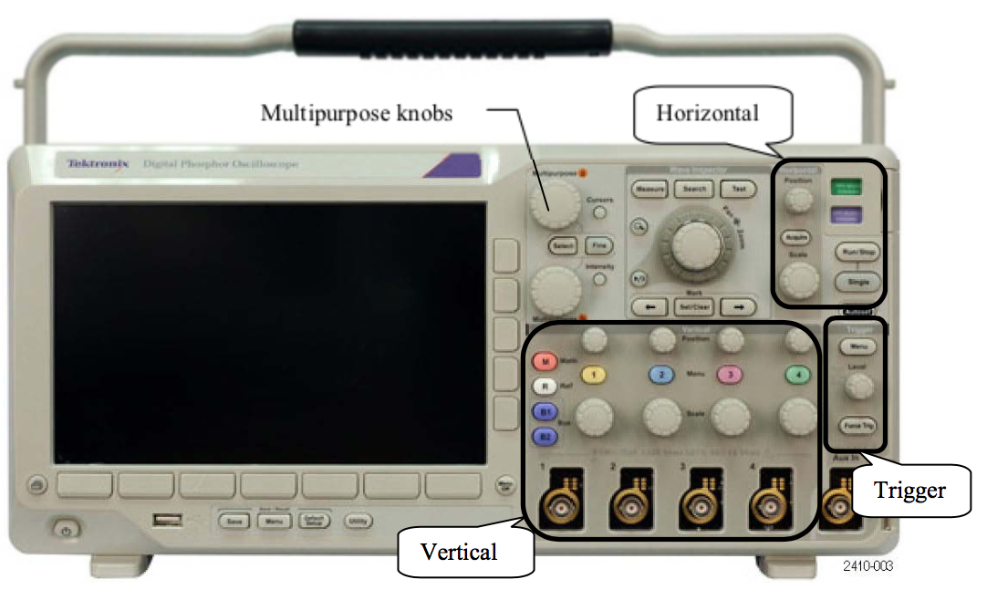

Measurements were made in ENG 249 Station 5 on September 22, 2016 using:

* Tektronix DPO 3012 Oscilloscope
* HP 33120A Function Generator (S/N: C010482)

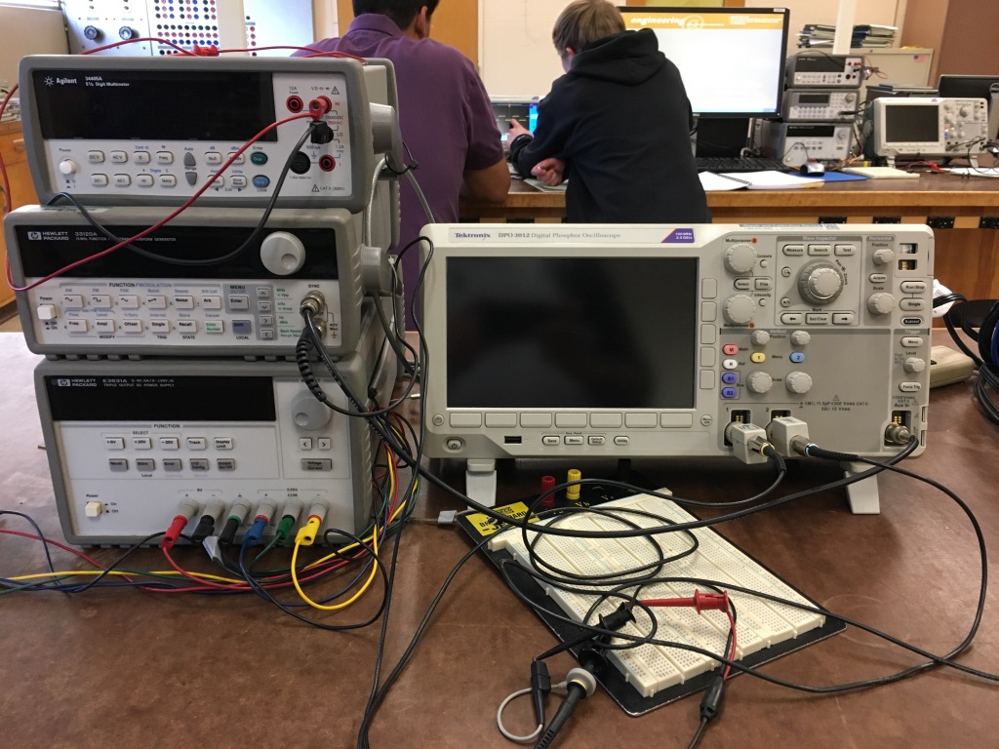

**Part A**

During this part, a waveform was generated by the function generator and displayed on the oscilloscope. The function generator was set to create a 1kHz sinusoidal waveform with a peak-to-peak voltage of 1V and zero offset. The probes of the oscilloscope were connected to the function generator as shown with a 100Ω resistor across the connection as shown.

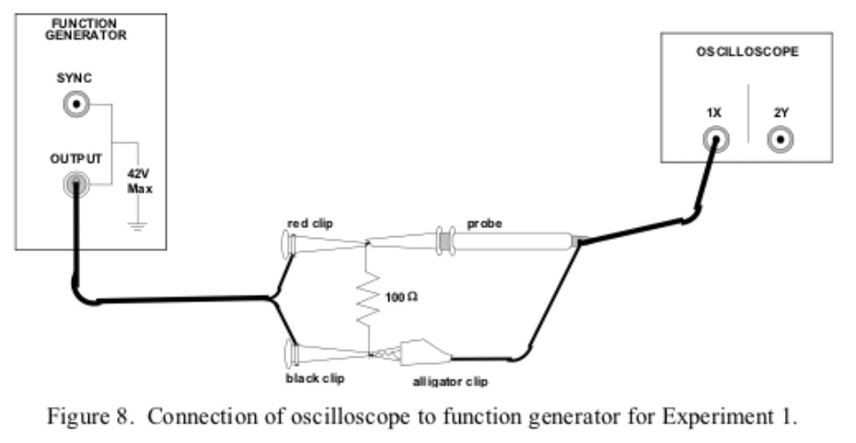

Here is an image of the waveform produced.

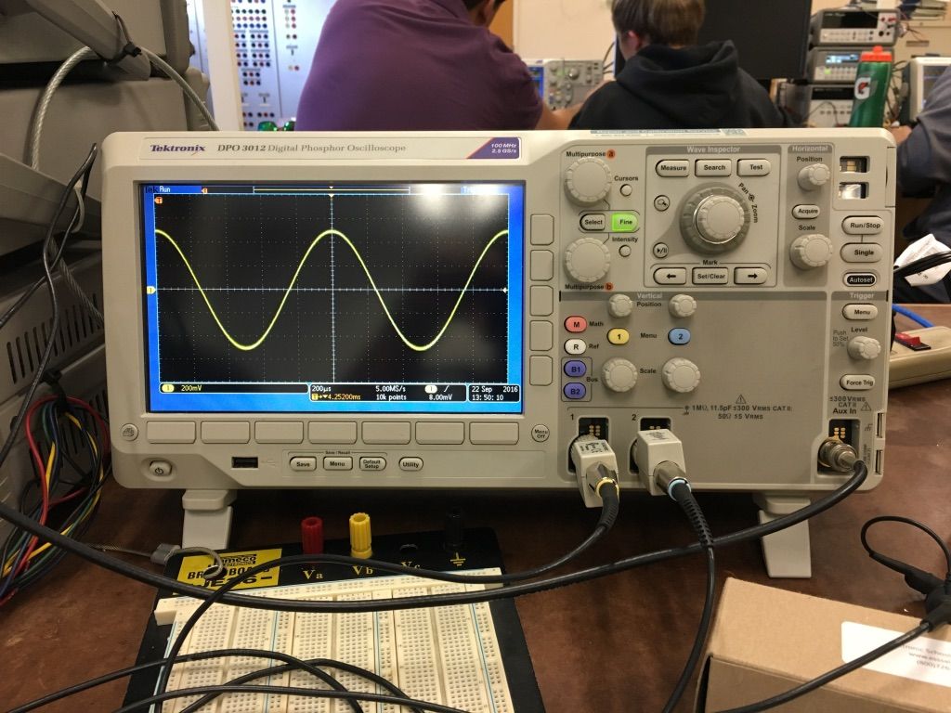

With the resistor removed, the peak-to-peak voltage of the waveform was measured to be 1V. This measured value matches the produced 1V Vpp by the function generator.

With the resistor added to the circuit, the peak-to-peak voltage of the waveform was measured to be about 640mV. This can be explained with Ohm’s Law – as resistance is added, voltage is lowered.

**Part B**

The setup was returned to default without the resistor connected. When the trigger channel was changed to a channel other than channel 1, the waveform became unstable. This is because the trigger controls should be matched to the correct channel if the waveform is to be stable. Changing the trigger settings to a different channel will create a mismatch between what trigger is needed and what is actually being used. This results in a refresh rate that doesn’t match the rate the waveform is produced at.

The waveform will also become unstable when the trigger level is moved above the scope of the waveform. As the trigger level moves about the waveform, the trigger rate adjusts accordingly to match the offset. When the trigger is moved off of the waveform, there’s no correlation between trigger settings and the waveform and the waveform becomes unstable.

The oscilloscope offers several options to freeze the waveform or keep it displayed in real-time depending on the needs of the experiment.

**Part C**

This part demonstrates the vertical scaling controls of the oscilloscope.

To display a sinusoidal waveform with a Vpp of 10V, you need a V/div scale of 5V.

To verify, the offset of the function generator, simply count the V/div to a point on the waveform. For this part, the V/div should add up to 1V, matching well with the 1V offset introduced by the function generator.

When using AC coupling to display a DC waveform with an offset value, the AC coupling will ignore the DC offset and display the waveform as if there is no offset.

Other instructions in this part demonstrate the 2nd channel of the oscilloscope and how to adjust the position and scale of the waveform using the vertical controls.

**Part D**

To verify the frequency of the waveform, count the Time/div horizontally. Then, use f = 1/time to find the frequency. The oscilloscope displays a waveform accurate to what the function generator is producing.

37kHz Wave:

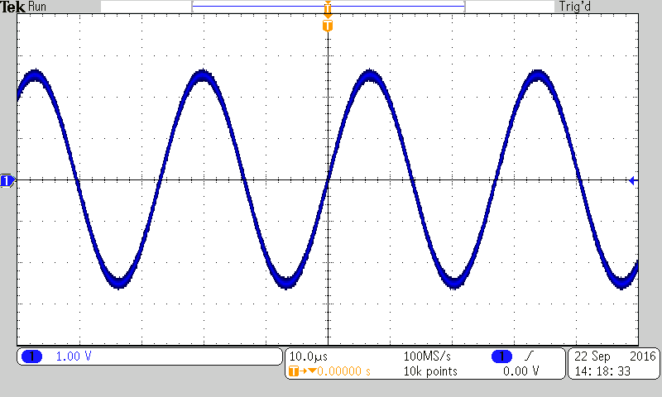

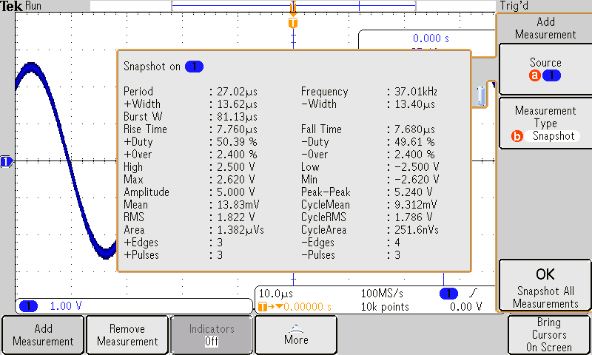

Experiment 1 was incredibly useful in understanding the various functions of the oscilloscope. It’s a powerful tool with several controls to fine tune the graph of even the wildest waveform.

**Experiment 2**

Oscilloscopes will be used extensively throughout this course. It’s crucial that one understands how to properly display a waveform on the oscilloscope. In this experiment, my partner and I tested each other by setting up a random waveform on the function generator and resetting the controls on the oscilloscope arbitrarily.

Measurements were made in ENG 249 Station 5 on September 22, 2016 using:

* Tektronix DPO 3012 Oscilloscope
* HP 33120A Function Generator (S/N: C010482)

Here is an image of the waveform I had to display properly:

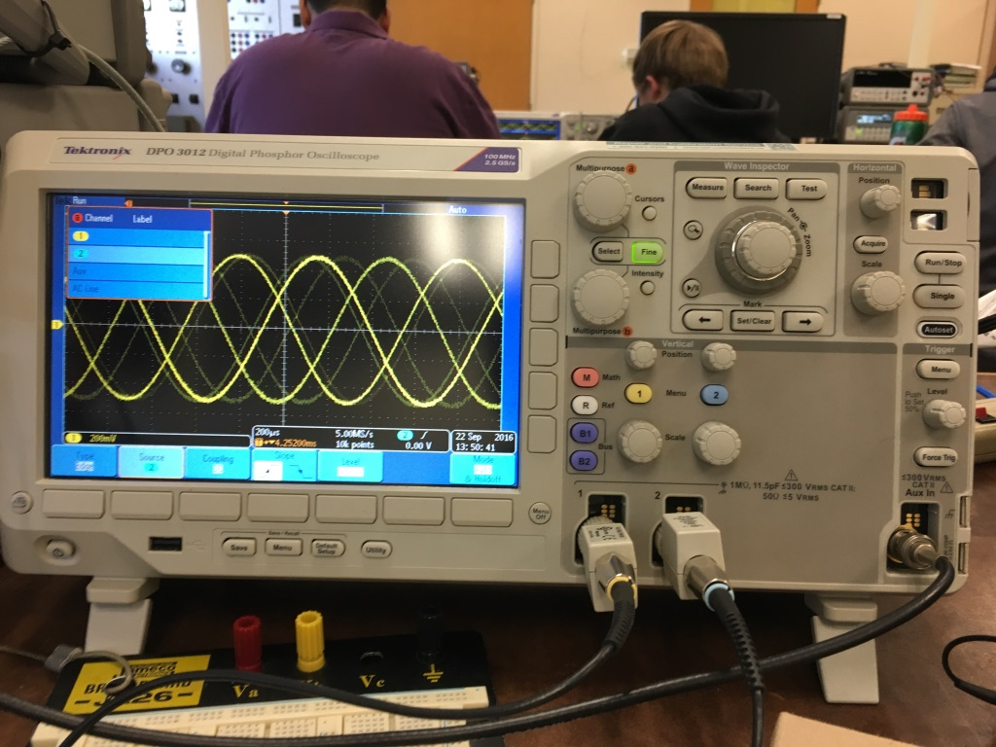

**Experiment 3**

In this experiment, we try to display two waveforms at once. One waveform, a 1kHz triangular wave with a Vpp of 1V and zero offset, is displayed on channel 1. Another waveform, a 1kHz square wave with a Vpp of 2.5V and zero offset, is displayed on channel 2.

Measurements were made in ENG 249 Station 5 on September 22, 2016 using:

* Tektronix DPO 3012 Oscilloscope
* HP 33120A Function Generator (S/N: C010482)

Here is an image of the produced waves:

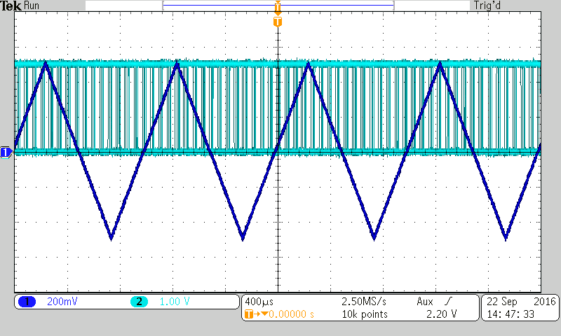

The goal of the experiment was to stabilize both waves on the oscilloscope. Unfortunately, this is impossible as each waveform features a different trigger rate. It’s impossible to find a middle ground to display both waveforms. Only one waveform can be stabilized at a time unless both waveforms had a similar refresh rate.

**Experiment 4**

The oscilloscope offers two different coupling methods, AC and DC. In this experiment, we examine the effects of DC coupling vs. AC coupling on a displayed waveform. The function generator was set up to generate a 5V, 20Hz wave with zero offset.

Measurements were made in ENG 249 Station 5 on September 22, 2016 using:

* Tektronix DPO 3012 Oscilloscope
* HP 33120A Function Generator (S/N: C010482)

When the input coupling is changed to AC coupling from DC coupling, there is a slight distortion. This can be explained by the internal circuitry in the oscilloscope. An image is below that shows the circuitry.

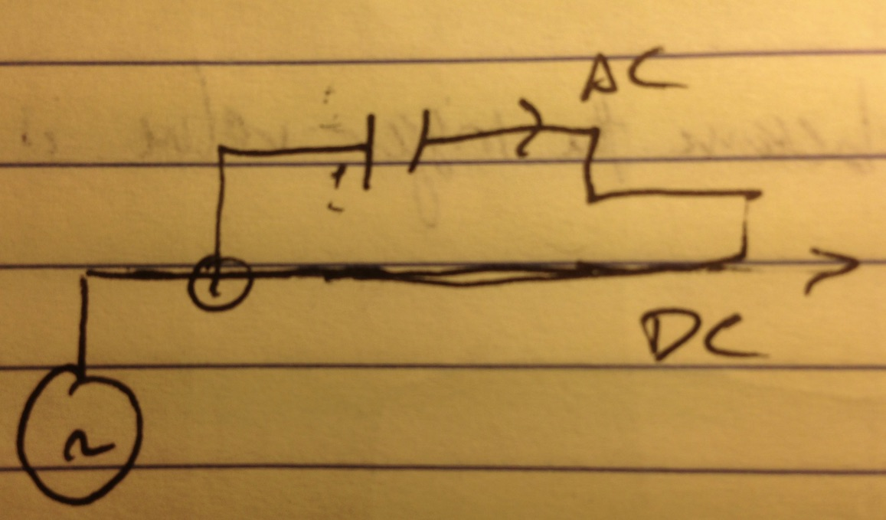

AC coupling seems like the way to go if using an AC voltage source. AC coupling would eliminate any distortion thanks to its built in capacitor.

**Experiment 5**

This experiment compares voltage measurements made using an oscilloscope to those using an Agilent Digital Multimeter.

Measurements were made in ENG 249 Station 10 on September 29, 2016 using:

* Agilent Digital Multimeter (DMM) (S/N: TW48090264)
* Tektronix DPO 3012 Oscilloscope
* HP 33120A Function Generator (S/N: C010482)

A rough picture is attached showing the setup:

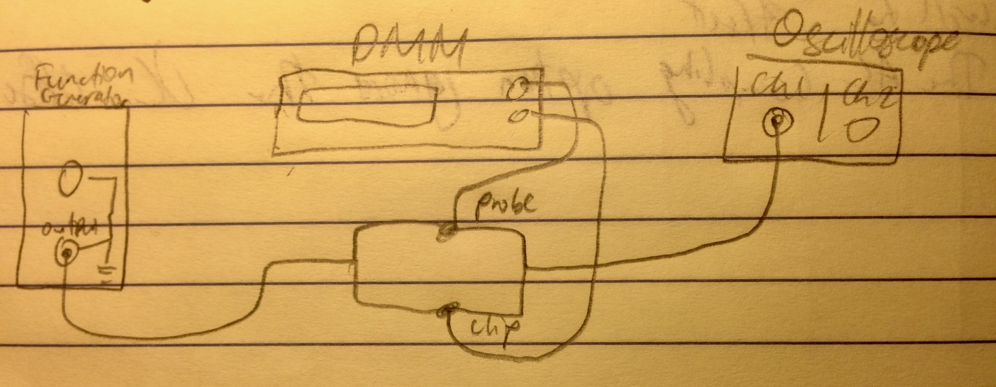

Data and logarithmic graphs are displayed on the following pages.

|  |  |  |
| --- | --- | --- |
| **Frequency [Hz]** | **Output Voltage** | **Column1** |
|  | **Oscilloscope (Vpp) [V]** | **DMM (Vrms) [V]** |
| 50 | 0.802141933 | 0.2836 |
| 100 | 0.80225507 | 0.28364 |
| 150 | 0.802311638 | 0.28366 |
| 200 | 0.802339923 | 0.28367 |
| 250 | 0.802339923 | 0.28367 |
| 300 | 0.802368207 | 0.28368 |
| 350 | 0.802085364 | 0.28358 |
| 400 | 0.802368207 | 0.28368 |
| 450 | 0.802368207 | 0.28368 |
| 500 | 0.802368207 | 0.28368 |
| 550 | 0.802396491 | 0.28369 |
| 600 | 0.802368207 | 0.28368 |
| 650 | 0.802396491 | 0.28369 |
| 700 | 0.802368207 | 0.28368 |
| 750 | 0.802368207 | 0.28368 |
| 800 | 0.802368207 | 0.28368 |
| 850 | 0.802368207 | 0.28368 |
| 900 | 0.802396491 | 0.28369 |
| 950 | 0.802368207 | 0.28368 |
| 1000 | 0.802368207 | 0.28368 |
| 1500 | 0.802339923 | 0.28367 |
| 2000 | 0.802339923 | 0.28367 |
| 2500 | 0.802339923 | 0.28367 |
| 3000 | 0.802339923 | 0.28367 |
| 3500 | 0.802368207 | 0.28368 |
| 4000 | 0.802396491 | 0.28369 |
| 4500 | 0.802396491 | 0.28369 |
| 5000 | 0.802396491 | 0.28369 |
| 5500 | 0.802396491 | 0.28369 |
| 6000 | 0.802368207 | 0.28368 |
| 6500 | 0.802339923 | 0.28367 |
| 7000 | 0.802339923 | 0.28367 |
| 7500 | 0.802311638 | 0.28366 |
| 8000 | 0.802226785 | 0.28363 |
| 8500 | 0.802141933 | 0.2836 |
| 9000 | 0.802028796 | 0.28356 |
| 9500 | 0.801915658 | 0.28352 |
| 10000 | 0.801774237 | 0.28347 |
| 80000 | 0.799285221 | 0.28259 |
| 160000 | 0.785001664 | 0.27754 |
| 240000 | 0.739039723 | 0.26129 |
| 320000 | 0.647483537 | 0.22892 |
| 400000 | 0.528378471 | 0.18681 |
| 480000 | 0.412441243 | 0.14582 |
| 560000 | 0.317264671 | 0.11217 |

Looking at the graphs for the Frequency vs. Vpp and Frequency vs. Digital Multimeter, it appears that the measured voltage is within the 70.7% acceptable value. Only when the frequency gets above 240,000Hz does the voltage start to dip below the 70% accuracy.

**Experiment 6**

The oscilloscope has a few more functions not yet discussed throughout the lab. In this experiment we examine the math functions and the internal circuitry of the oscilloscope.

The circuit below is constructed. There are probes at point A, B, and C.

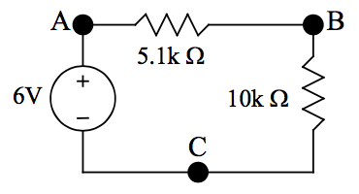

Measurements were made in ENG 249 Station 10 on September 29, 2016 using:

* Tektronix DPO 3012 Oscilloscope
* HP 33120A Function Generator (S/N: C010482)

Voltage across 10kΩ resistor is 0V.

Voltage across 5.1kΩ resistor is 6V.

The oscilloscope completes the circuit. Inside the oscilloscope, there is very little internal resistance. Because the probes are connected to point A and B, the circuit is completed and the rest of circuit after point B is ignored. All 6V of the power source is dissipated over the 5.1kΩ resistor.

**Conclusion**

The oscilloscope is an extremely powerful device for displaying the voltage vs. time of any input. In fact, an oscilloscope can display voltage vs. time graphs from two different sources at once. The oscilloscope also offers several functions to calculate the actual values of Vpp, frequency, etc. The oscilloscope can even perform math functions with two different channels.